______________________________________________________________________________________________________

Dear Parent/Guardian
COLLECTION ARRANGEMENTS AT HOMETIME 2021-22
All children in school must be collected by a named adult at the end of the school day (including clubs). The adult collecting your child needs to be 18 years or over.
Please complete and return the slip below as soon as possible with any changes to the list from last year to inform us who has permission to collect your child as without your permission your child will not be handed over.
If your child is in Years 5 or 6 and you want them to walk home alone, you must be complete the ‘Walking home alone’ slip and return this to your child’s class teacher as soon as possible, as without your permission they will not be allowed to walk home alone.
Yours sincerely
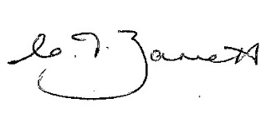
C Barrett
Headteacher
…………………………………………………………………………………………………………………………………………….………………………
COLLECTION ARRANGEMENTS AT HOMETIME 2021-22
Child’s name …………………………………………………………………….. Class ………………………………..
My child will be collected by:
Name of adult ……………………………………………………………………. Relationship ……………………….………………………..
Name of adult ……………………………………………………………………. Relationship ……………………….………………………..
Name of adult ……………………………………………………………………. Relationship ……………………….………………………..
Name of adult ……………………………………………………………………. Relationship ……………………….………………………..
Name of adult ……………………………………………………………………. Relationship ……………………….………………………..

