

YOU COULD BE A GOVERNOR IF:

You are aged 18 or over
You are interested in education and would like to support a school
You want to contribute to your community
You can spare about 6-8 hours per month
You can work as part of a team
You are willing to take on responsibility

There isn’t an upper age limit, you don’t have to have prior knowledge, experience or specific qualifications.

Governors come from all walks of life; what they share is the difference they make to the lives of Newcastle’s children.
Governors work in partnership with the school staff to provide the highest possible standards of education and to help all children aspire to the highest expectations.
Governors provide strategic management , challenge and accountability.
They do this by:

Setting the school’s aims and values
Promoting high standards of achievement
Planning the school’s long term future
Managing the budget
Appointing leaders

SCHOOL GOVERNORS ARE PEOPLE LIKE YOU

Find out what’s involved

Governance can be a really rewarding, enjoyable and stimulating experience. You are playing a valuable part in ensuring children get the best possible start in life; learning new skills and developing existing ones.

E-mail: governorservices@newcastle.gov.uk


Contact Us
Newcastle City Council
Governor Services
Children’s Services
Room 400
Civic Centre
Newcastle Upon Tyne NE1 8PU
Telephone: (0191) 211 5319

Email us at: governorservices@newcastle.gov.uk

HELP TO MAKE A DIFFERENCE TO OUR CHILDREN
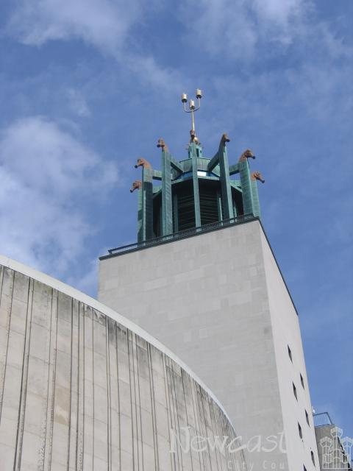

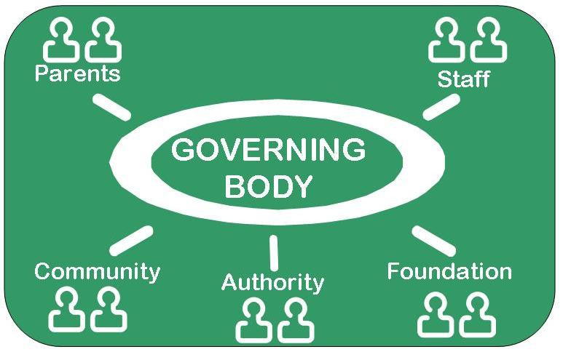

E-mail: governorservices@newcastle.gov.uk
Contact Us
Newcastle City Council
Governor Services
Children’s Services
Room 400
Civic Centre
Newcastle Upon Tyne NE1 8PU
Telephone: (0191) 211 5319

WHO SITS ON A GOVERNING BODY
Parent Governors: parents of a child at the school and elected by the parents. Contact the school directly for details of any vacancies
Staff Governors: The Headteacher plus members of the teaching or support staff elected by other staff
Community Governors: appointed by the governing body, often bring specific skills or links with the community. Contact Governor Services for details
Authority Governors: appointed by the Local Authority. Contact Governor Services for details of any vacancies.
Foundation Governors: appointed to faith or trust schools, by the Diocese or other partner organisations.

BECOME A
SCHOOL GOVERNOR
IN NEWCASTLE
HELP TO MAKE A DIFFERENCE TO OUR CHILDREN

Governor Services:

(0191) 211 5319
WHAT DOES BEING
A GOVERNOR INVOLVE?

Time — schools have full governing body meetings once or twice a term, usually late in the afternoon or evening and you will also be asked to join one or more committees. You will also need to find some time throughout the year to visit school or attend events *.

Training — there will be an expectation that you will undertake some training to help you understand the role.

Term of office — governors have a four year term of office, but many of our governors serve for more than one term of office!

*Many employers allow some paid time off work for governor duties.

